Guillotine to cut extruded food
The servomotor driven guillotine is placed at the end of the extrusion line to cut the extruded ropes or sheet material into controlled lengths from 5 mm to 1 m or longer. The belt carries the product under the blade so that it can be cut to controlled lengths via feedback from the conveyor belt drive. The blade advances with the product as it is being cut to keep the cut pieces true and square. Cut speeds up to 350 cuts per minute are possible with cut heights up to 20 mm. Taller product can be cut at lower speeds.
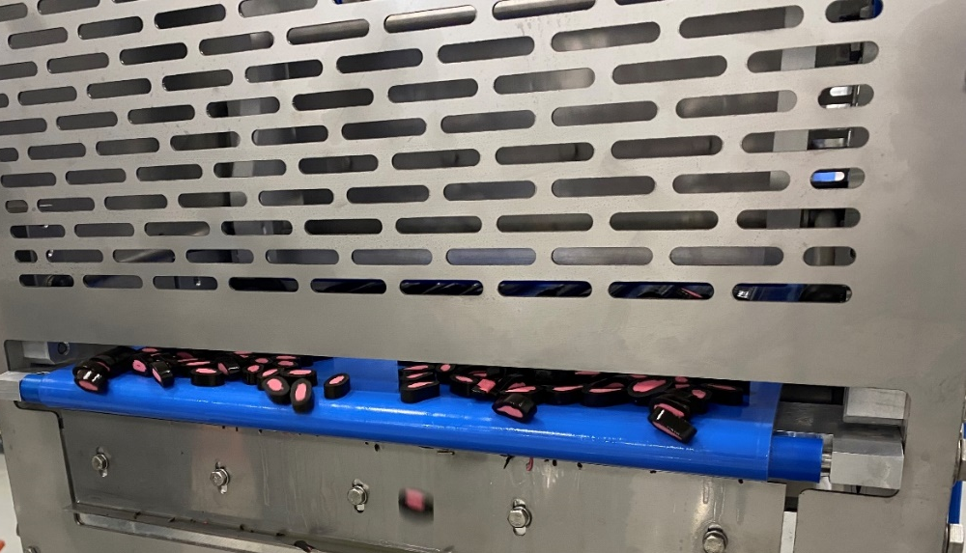
The Mattoc guillotine is available in 4 cutting widths: 400, 800, 1200 and 1600 mm and can be supplied with ultrasonic cutting blades for sticky or fragile products.
Mattoc also supply complimentary slitting and spreading equipment to slit sheet product into lines prior to them being cross cut to length by the guillotine.

Mattoc Confectionery Engineering Ltd www.mattocce.com

